Final Project Template

Identify the vulnerability | What harm could it do? | How to fix it
- The file /var/www/html/comments.txt can be written by anyone. I found that the file’s permissions are set to -rw-rw-rw, so that’s why any local user can modify it.  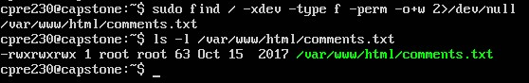 | An attacker could inject any malicious scripts in our site and lead it to phishing of pages any local user can modify this file.  (https://stackoverflow.com/questions/53848467/risk-about-world-writable-file?utm) | - Remove the permission for others to write and edit the file  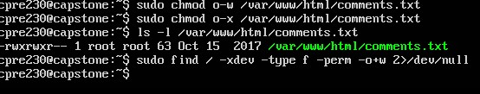
- The files such as vulns_here and hacks_here which are under the directory /srv/ftp can be written by anyone as the permissions in these files have been set to drwxrwxrwx.  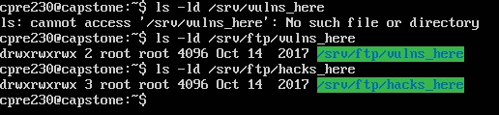 | An attacker can plant a malware, upload web shells or any phishing files as any user can drop-in any kind of files over here. Once its placed over there, the malicious code can be served directly which gives the attacker an easy point to enter a system.  (https://owasp.org/www-community/vulnerabilities/Unrestricted_File_Upload?utm) | - Remove the permission from the others to write or edit anything in these files.  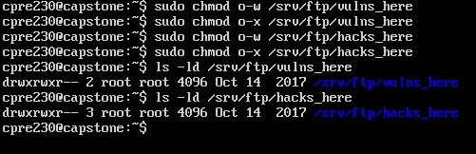
- I observered some rogue vague accounts over here. Ovver here we can see that the userbackdoor has a UID of 0 ( which means it can easily gain the root access) and also has some valid shells. Secondly, we can observe user bob is in sudo and lastly, user alex can be seen in the admin group.  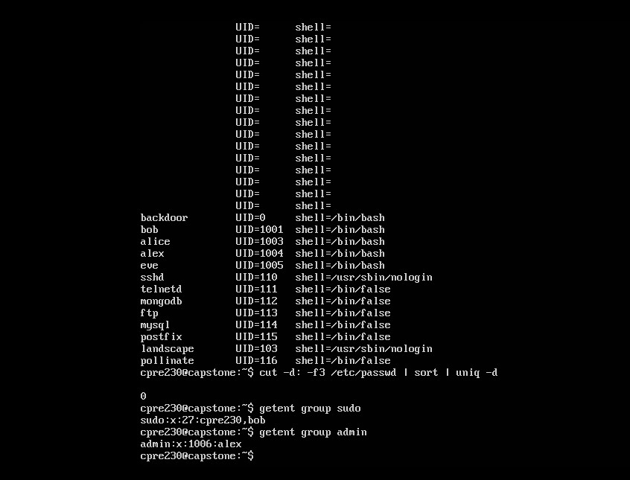 | These accounts can gain full root privileges, install malware and delete any important data.They can install any software, read or delete any files, disable any security controls or create any additional backdoors  (https://cwe.mitre.org/data/definitions/269.html?utm) | - Delete user bob from the sudo group  - Delete user Alex from the admin group.  (https://cwe.mitre.org/data/definitions/269.html?utm)  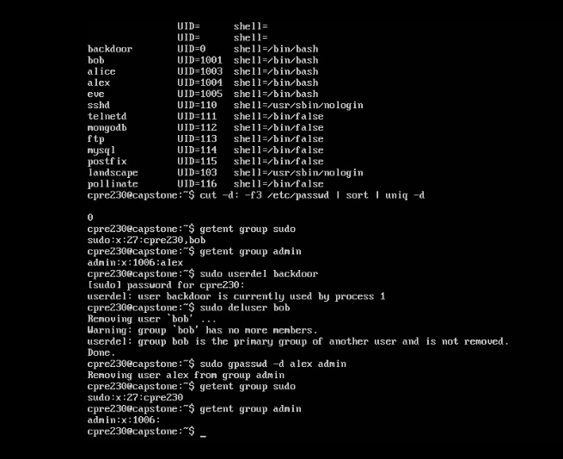  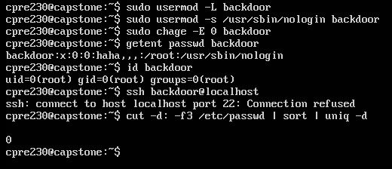
- Plaintext ftp and telnet authentication. On port 21, FTP sends a USER/PASS cleartext and Telnet on port 23 is entirely encrypted.  (https://en.wikipedia.org/wiki/File_Transfer_Protocol?utm)  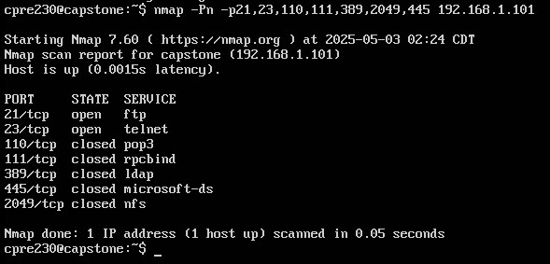 | Telnet and FTP are quite old technologies which lack some security authentication. Over here we can see that on port 21, FTP is sending the username and password in cleartext and it also accepts the local username over an unencrypted channel which allows any credentials to be sniffed on wireshark or tcpdump and malicious files could be uploaded because of that. Similar to TCP, telnet transmits all data unencrypted on port 23 which could be captured by any packet sniffer.  (https://en.wikipedia.org/wiki/Telnet?utm) | - Disable or remove ftp and telnet  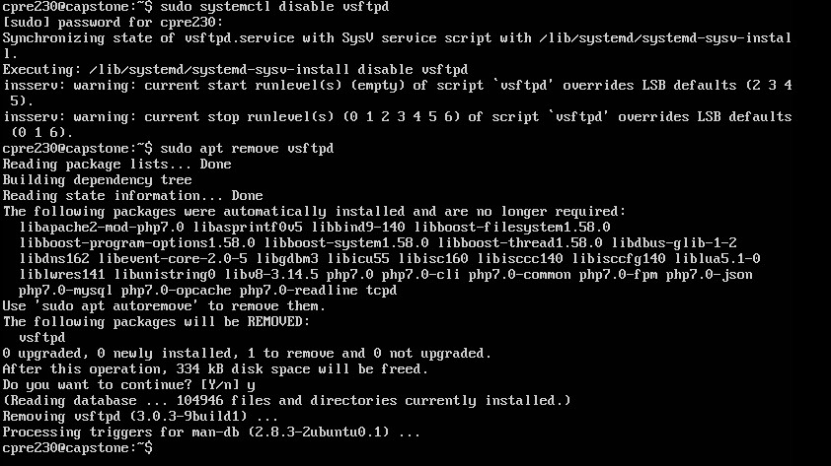  - Configure /etc/vsftpd.conf and set ssl_enable = Yes, in order to configure vsftpd with TLS  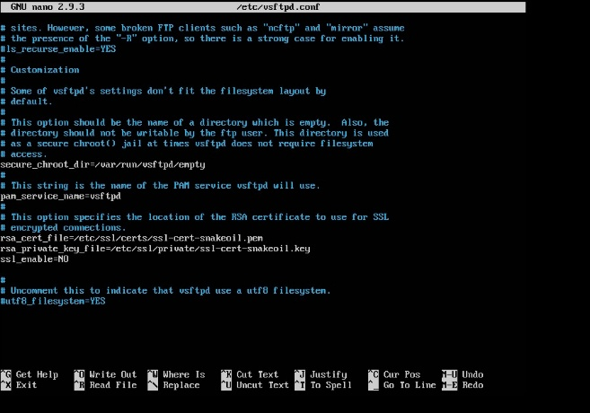  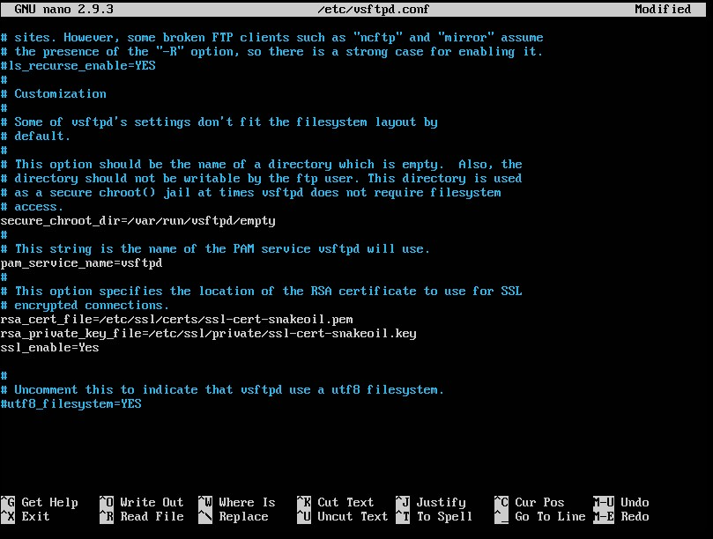
- Weak SSH configuration and missing host keys. Over here the host-key files are not generated as PermitRootLogin and PasswordAuthentication have been set to yes.  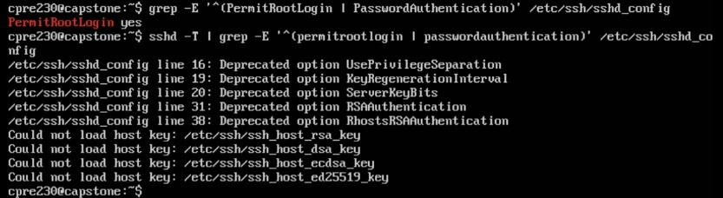 | It allows some direct root SSH logins, which means that it bypasses the sudo login, and prevents any clients from verifying the server’s identity which may be used for credential brute-force on the root account.  (https://superuser.com/questions/1641346/how-can-permitrootlogin-no-add-security?utm) | One must edit the /etc/ssh/sshd_config and change the permission for PermitRootLogin and PasswordAuthentication to no. Then do ssh-keygen -A anjd restart the ssh by doing systemctl restart ssh.  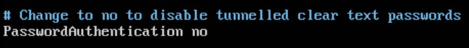  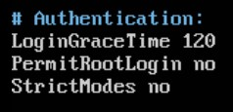  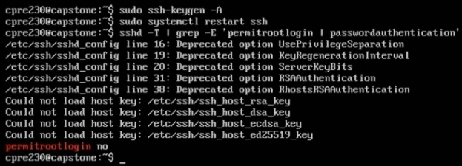  (https://www.tecmint.com/disable-or-enable-ssh-root-login-and-limit-ssh-access-in-linux/?utm)
- The http version is being disclosed. Over here the apache default pages and headers show server, that is, Apache/2.4.29 (Ubuntu).  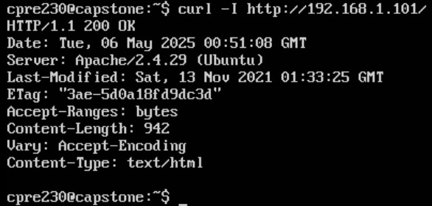 | It exposes the exact Apache version so it makes an attacker’s work easier as he can look up and exploit any publicly known CVEs specific to that release for denial-of-service. A CVE  Is like an identifier for a known software or hardware security flaw. Its main purposes are to give every vulnerability a unique and easy-to-reference name and to enable consistent sharing of information about it across tools, advisories, and databases.  (https://www.petefreitag.com/blog/servertokens-serversignature/?) | We must edit the /etc/apache2/conf-available/security.conf and change the ServerSignature to off, ServerTokens to Prod and then save the file. After that do that a2enconf security && systemctl reload apache2.  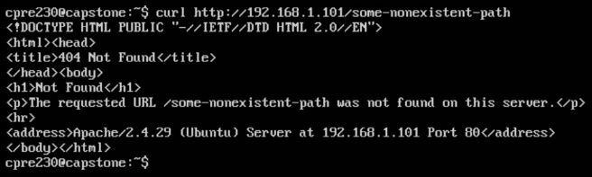  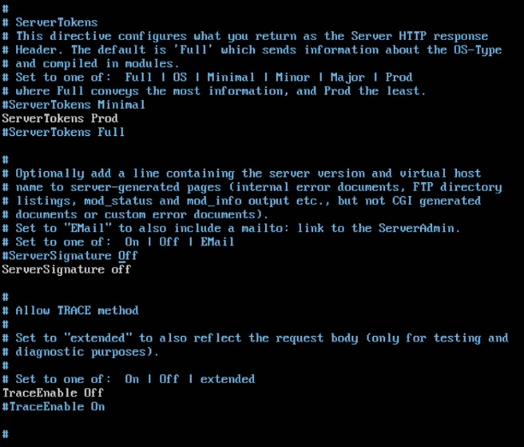  (https://blog.oshim.net/2016/04/turn-off-server-signature-on-apache-web/)
- /login.php does not have any protection, that is it can be accessed by anyone as when we type curl -I http://192.168.1.101/login.php as it shows HTTP/1.1 200 authorized which means that it can be accessed by anyone.  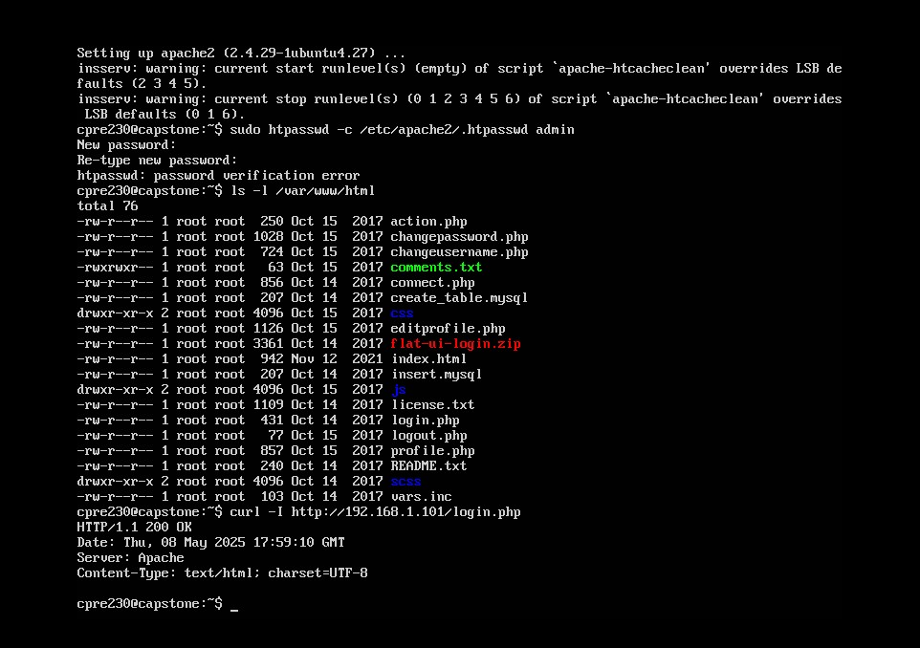 | It exposes the admin interface to brute force and vulnerability scanning, creating a high risk of compromising the full administrative rights and taking over of the web application by the attacker.  (https://www.digitalocean.com/community/tutorials/how-to-set-up-password-authentication-with-apache-on-ubuntu-14-04?utm) | Edit the file /etc/apache2/sites-available/000-default.conf and add the following lines:  <Location /login.php>  AuthType Basic  AuthName "Admin Area"  AuthUserFile /etc/apache2/.htpasswd  Require valid-user  </Location>  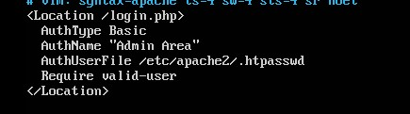  And then reload it and verify by using the command curl -I http://192.168.1.101/login.php that you get something as HTTP/1.1 401 Unauthorized which means that it cannot be accessed by anyone right now.  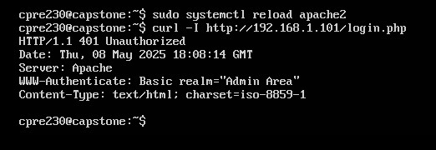  (https://www.digitalocean.com/community/tutorials/how-to-set-up-password-authentication-with-apache-on-ubuntu-14-04?utm)

Please draw a network diagram illustrating the comprehensive network infrastructure established over the semester. This diagram should resemble Lab 4's layout but should provide a thorough depiction of the network, including each configured machine placed appropriately with their respective services, ports, and IP addresses indicated.
- All network resources must be assigned an IP address.
- Any necessary port forwarding should be annotated on the Firewall/NAT (excluding UFW firewall rules).
- The LDAP workstation and the Kali Box do not need to be included.
- Ensure the inclusion of virtual IP port forwarding within the diagram.

Insert diagram below:

(Please refer to the next page)

Network Diagram:

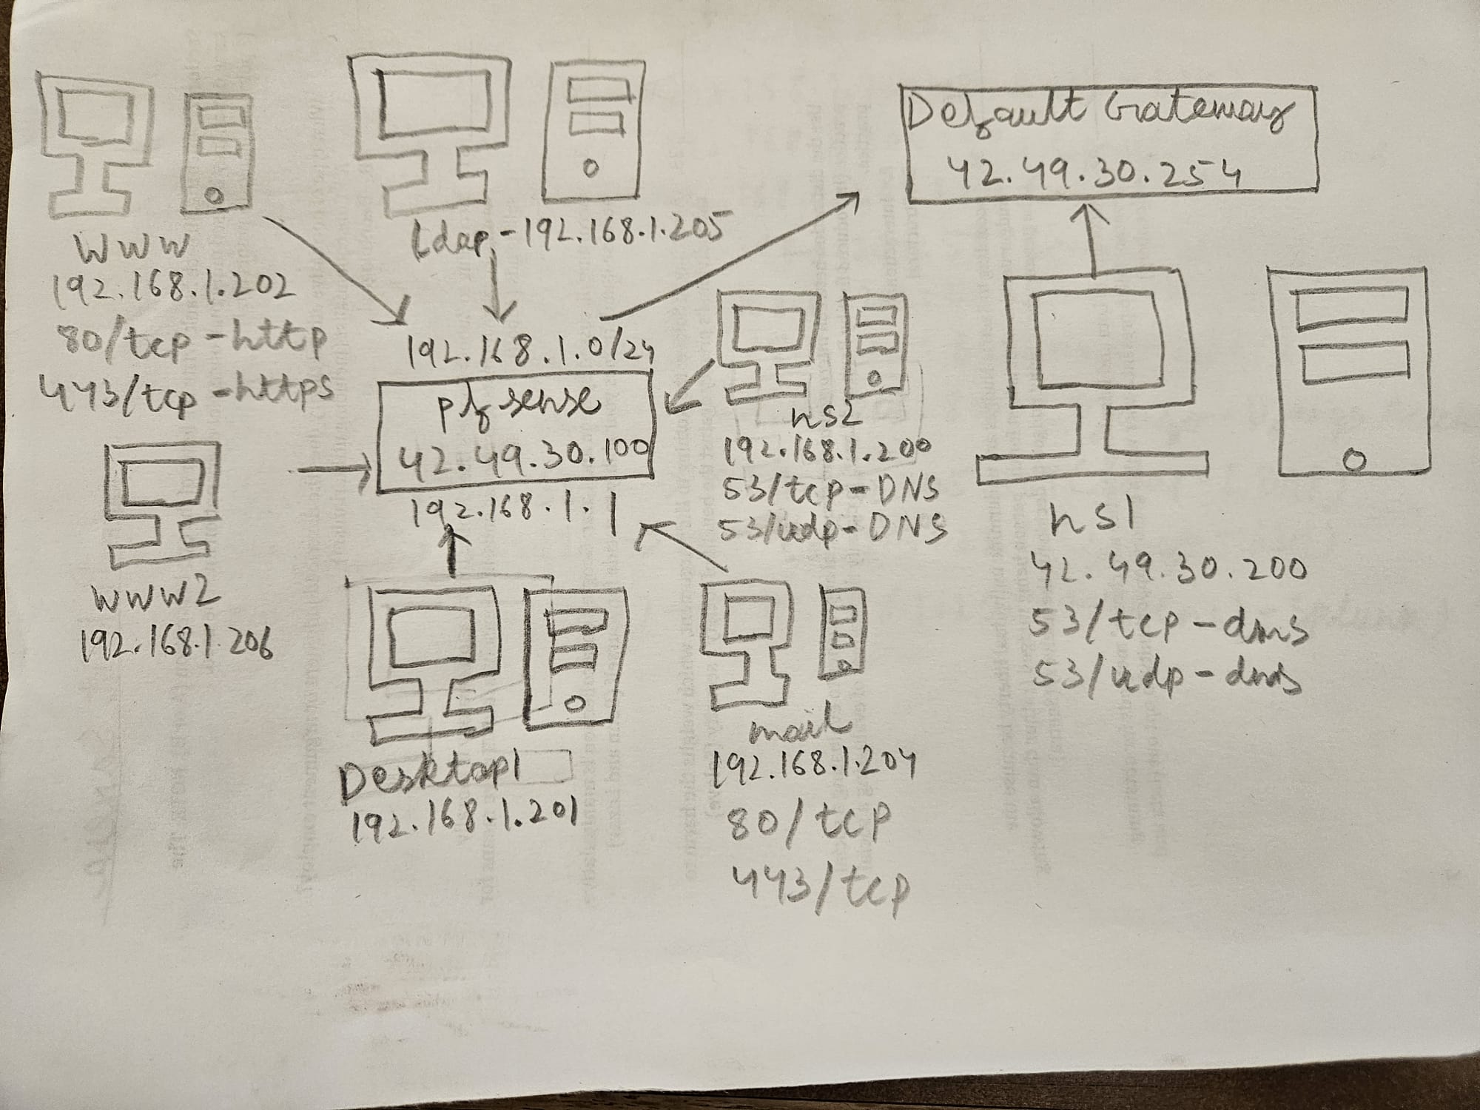

Port Forwarding:

